# ECE 162 Lab 1 Experiment 1a

Name: Brian Loughran (btl217@lehigh.edu)

## Purpose

In this lab we will be measuring the equivalent resistance of resistors in both parallel and series.

## Theory

Common orientation of resistors in a circuit includes elements that are in series and those that are in parallel. Finding equivalent resistance for these resistors can be useful in examining or designing the circuit. To calculate the theoretical value of two resistors measured in series, the following equation can be used:

Rtot = R1 + R2 + R3 + ... (eq. 1)

Where Rtot is the equivalent resistance of all the elements in series of the circuit, and R1, R2, etc, are the individual resistor elements. If you want to calculate the equivalent resistance of elements in parallel, the following equation can be utilized:

$\frac{1}{R_{tot}}= \frac{1}{R_{1}}+ \frac{1}{R_{2}}+ \frac{1}{R_{3}}+ …$ (eq. 2)

Using these two equations, most circuits can be broken down to an equivalent resistance, and analyzed to find current or voltage. For this lab we are only using two resistors in both circuits, so the R3 term drops out.

## Experimental Method

* Take a 680 Ω resistor and a 5.6 k Ω resistor, and measure their resistance using the AVO meter
* Connect the two resistors in series on the protoboard and measure and record the equivalent resistance
* Connect the two resistors in parallel on the protoboard and measure and record the equivalent resistance
* Compare the experimental values of equivalent resistance with the calculated ones.

## Diagram

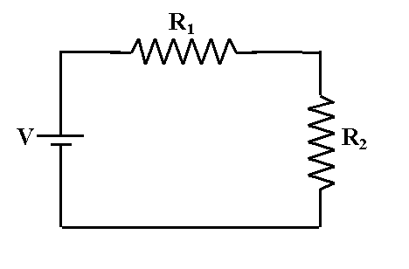Shown below is a diagram of the circuit in series. The power supply in this diagram is actually the AVO meter, as it outputs a voltage to measure the resistance, and it is connected on both sides of the resistors in series. It is important that there is not another power supply connected to the system, as this could damage the AVO.

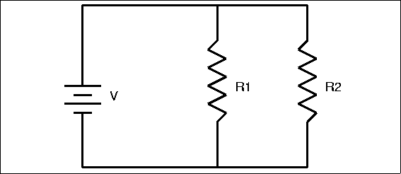Below is the diagram for the circuit in parallel. Again, the power supply is the AVO meter.

## Results

The results for these two measurements are shown in the table below. Theoretical equivalent values are calculated using equations 1 and 2.

|  |  |  |
| --- | --- | --- |
| Series equivalent R experimental | Series equivalent R theoretical | % error |
| 6260 Ω | 6280 Ω | 0.32 % |
| Parallel equivalent R experimental | Parallel equivalent R theoretical | % error |
| 606.2 Ω | 606.37 Ω | 0.028 % |

## Discussion

For this series of experiments nothing was too unexpected. Because of the simplicity of the circuit, as well as the simplicity of the experiment performed, nothing was particularly surprising about the results. Percent error was very low in this experiment. This can be credited to the accuracy of the instruments being used to measure the equivalent resistances as well as the simplicity of the circuit.

## Conclusion

This was a simple experiment, but it proved Ohm’s Law (equations 1 and 2) to be true for two resistor systems. Ohm’s law is used extensively in the real world, so it is nice to see in lab that it works, and that it is highly accurate.